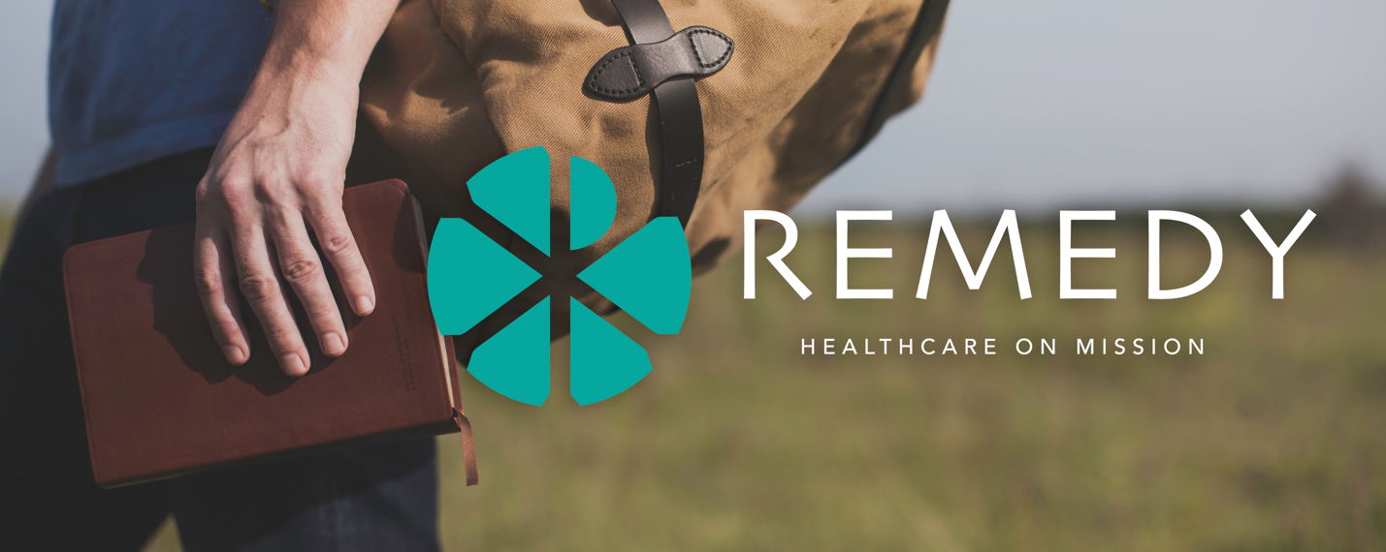

Ideas for social media promos/ quick hitters:
- Wondering how you can live missionally in healthcare in 2025? Join like-minded Christ-following students and professionals to grow and explore together at Remedy West @ CBU Oct 17-18. Sign up today!
- Life on mission. Healthcare worker. Mutually exclusive? We don’t think so. Join us for Remedy West @ CBU Oct 17-18. and be inspired. Sign up today!
- What do Christian nurses, therapists, physicians, optometrists, hospital administrators, allied health workers, and students/ trainees in all of these fields have in common? They should all be at Remedy West @ CBU Oct 17-18, being equipped to live missionally as healthcare workers. Sign up today!
- Med students- Need to remember why you’re doing this? Remedy West @ CBU Oct 17-18, Healthcare on Mission. Don’t miss it- sign up today!
- Nursing students- Need to remember why you’re doing this? Remedy West @ CBU Oct 17-18, Healthcare on Mission. Don’t miss it- sign up today!
- Join a phenomenal group of speakers and exhibitors at Remedy West @ CBU Oct 17-18, Healthcare on Mission. Sign up today!
- Remedy West is back this fall. Join us October 17-18 at Cal Baptist University.
- For many, missional living happens in our communities, institutions, & workplaces here in the US. What does it look like for you? Learn and do at Remedy West @ CBU Oct 17-18.

